SYSTEM DESIGN

%3CmxGraphModel%3E%3Croot%3E%3CmxCell%20id%3D%220%22%2F%3E%3CmxCell%20id%3D%221%22%20parent%3D%220%22%2F%3E%3CmxCell%20id%3D%222%22%20value%3D%22Django%20Application%22%20style%3D%22whiteSpace%3Dwrap%3BstrokeWidth%3D2%3BfillColor%3D%23FFE599%3BstrokeColor%3D%23FFE599%3B%22%20vertex%3D%221%22%20parent%3D%221%22%3E%3CmxGeometry%20x%3D%2220%22%20y%3D%22124%22%20width%3D%221264%22%20height%3D%22104%22%20as%3D%22geometry%22%2F%3E%3C%2FmxCell%3E%3CmxCell%20id%3D%223%22%20value%3D%22User%22%20style%3D%22rounded%3D1%3BarcSize%3D20%3BstrokeWidth%3D2%3BfillColor%3D%23FFE599%3BstrokeColor%3D%23FFE599%3B%22%20vertex%3D%221%22%20parent%3D%221%22%3E%3CmxGeometry%20x%3D%22510%22%20y%3D%2220%22%20width%3D%2262%22%20height%3D%2254%22%20as%3D%22geometry%22%2F%3E%3C%2FmxCell%3E%3CmxCell%20id%3D%224%22%20value%3D%22User%20Registration%22%20style%3D%22whiteSpace%3Dwrap%3BstrokeWidth%3D2%3BfillColor%3D%23FFE599%3BstrokeColor%3D%23FFE599%3B%22%20vertex%3D%221%22%20parent%3D%221%22%3E%3CmxGeometry%20x%3D%2255%22%20y%3D%22149%22%20width%3D%22182%22%20height%3D%2254%22%20as%3D%22geometry%22%2F%3E%3C%2FmxCell%3E%3CmxCell%20id%3D%225%22%20value%3D%22User%20Login%22%20style%3D%22whiteSpace%3Dwrap%3BstrokeWidth%3D2%3BfillColor%3D%23FFE599%3BstrokeColor%3D%23FFE599%3B%22%20vertex%3D%221%22%20parent%3D%221%22%3E%3CmxGeometry%20x%3D%22287%22%20y%3D%22149%22%20width%3D%22135%22%20height%3D%2254%22%20as%3D%22geometry%22%2F%3E%3C%2FmxCell%3E%3CmxCell%20id%3D%226%22%20value%3D%22Forgot%20Password%22%20style%3D%22whiteSpace%3Dwrap%3BstrokeWidth%3D2%3BfillColor%3D%23FFE599%3BstrokeColor%3D%23FFE599%3B%22%20vertex%3D%221%22%20parent%3D%221%22%3E%3CmxGeometry%20x%3D%22472%22%20y%3D%22149%22%20width%3D%22176%22%20height%3D%2254%22%20as%3D%22geometry%22%2F%3E%3C%2FmxCell%3E%3CmxCell%20id%3D%227%22%20value%3D%22View%20Dataset%22%20style%3D%22whiteSpace%3Dwrap%3BstrokeWidth%3D2%3BfillColor%3D%23FFE599%3BstrokeColor%3D%23FFE599%3B%22%20vertex%3D%221%22%20parent%3D%221%22%3E%3CmxGeometry%20x%3D%22698%22%20y%3D%22149%22%20width%3D%22154%22%20height%3D%2254%22%20as%3D%22geometry%22%2F%3E%3C%2FmxCell%3E%3CmxCell%20id%3D%228%22%20value%3D%22Train%20Model%22%20style%3D%22whiteSpace%3Dwrap%3BstrokeWidth%3D2%3BfillColor%3D%23FFE599%3BstrokeColor%3D%23FFE599%3B%22%20vertex%3D%221%22%20parent%3D%221%22%3E%3CmxGeometry%20x%3D%22902%22%20y%3D%22149%22%20width%3D%22143%22%20height%3D%2254%22%20as%3D%22geometry%22%2F%3E%3C%2FmxCell%3E%3CmxCell%20id%3D%229%22%20value%3D%22Predict%20Score%22%20style%3D%22whiteSpace%3Dwrap%3BstrokeWidth%3D2%3BfillColor%3D%23FFE599%3BstrokeColor%3D%23FFE599%3B%22%20vertex%3D%221%22%20parent%3D%221%22%3E%3CmxGeometry%20x%3D%221094%22%20y%3D%22149%22%20width%3D%22155%22%20height%3D%2254%22%20as%3D%22geometry%22%2F%3E%3C%2FmxCell%3E%3CmxCell%20id%3D%2210%22%20value%3D%22User%22%20style%3D%22whiteSpace%3Dwrap%3BstrokeWidth%3D2%3BfillColor%3D%23FFE599%3BstrokeColor%3D%23FFE599%3B%22%20vertex%3D%221%22%20parent%3D%221%22%3E%3CmxGeometry%20x%3D%22622%22%20y%3D%2220%22%20width%3D%2292%22%20height%3D%2254%22%20as%3D%22geometry%22%2F%3E%3C%2FmxCell%3E%3CmxCell%20id%3D%2211%22%20value%3D%22%22%20style%3D%22curved%3D1%3BstartArrow%3Dnone%3BendArrow%3Dblock%3BexitX%3D-0.01%3BexitY%3D0.58%3BentryX%3D0.5%3BentryY%3D0%3Brounded%3D0%3BfillColor%3D%23FFE599%3BstrokeColor%3D%23FFE599%3B%22%20edge%3D%221%22%20source%3D%2210%22%20target%3D%224%22%20parent%3D%221%22%3E%3CmxGeometry%20relative%3D%221%22%20as%3D%22geometry%22%3E%3CArray%20as%3D%22points%22%3E%3CmxPoint%20x%3D%22146%22%20y%3D%2299%22%2F%3E%3C%2FArray%3E%3C%2FmxGeometry%3E%3C%2FmxCell%3E%3CmxCell%20id%3D%2212%22%20value%3D%22%22%20style%3D%22curved%3D1%3BstartArrow%3Dnone%3BendArrow%3Dblock%3BexitX%3D-0.01%3BexitY%3D0.64%3BentryX%3D0.5%3BentryY%3D0%3Brounded%3D0%3BfillColor%3D%23FFE599%3BstrokeColor%3D%23FFE599%3B%22%20edge%3D%221%22%20source%3D%2210%22%20target%3D%225%22%20parent%3D%221%22%3E%3CmxGeometry%20relative%3D%221%22%20as%3D%22geometry%22%3E%3CArray%20as%3D%22points%22%3E%3CmxPoint%20x%3D%22355%22%20y%3D%2299%22%2F%3E%3C%2FArray%3E%3C%2FmxGeometry%3E%3C%2FmxCell%3E%3CmxCell%20id%3D%2213%22%20value%3D%22%22%20style%3D%22curved%3D1%3BstartArrow%3Dnone%3BendArrow%3Dblock%3BexitX%3D-0.01%3BexitY%3D0.91%3BentryX%3D0.5%3BentryY%3D0%3Brounded%3D0%3BfillColor%3D%23FFE599%3BstrokeColor%3D%23FFE599%3B%22%20edge%3D%221%22%20source%3D%2210%22%20target%3D%226%22%20parent%3D%221%22%3E%3CmxGeometry%20relative%3D%221%22%20as%3D%22geometry%22%3E%3CArray%20as%3D%22points%22%3E%3CmxPoint%20x%3D%22560%22%20y%3D%2299%22%2F%3E%3C%2FArray%3E%3C%2FmxGeometry%3E%3C%2FmxCell%3E%3CmxCell%20id%3D%2214%22%20value%3D%22%22%20style%3D%22curved%3D1%3BstartArrow%3Dnone%3BendArrow%3Dblock%3BexitX%3D0.99%3BexitY%3D0.91%3BentryX%3D0.5%3BentryY%3D0%3Brounded%3D0%3BfillColor%3D%23FFE599%3BstrokeColor%3D%23FFE599%3B%22%20edge%3D%221%22%20source%3D%2210%22%20target%3D%227%22%20parent%3D%221%22%3E%3CmxGeometry%20relative%3D%221%22%20as%3D%22geometry%22%3E%3CArray%20as%3D%22points%22%3E%3CmxPoint%20x%3D%22775%22%20y%3D%2299%22%2F%3E%3C%2FArray%3E%3C%2FmxGeometry%3E%3C%2FmxCell%3E%3CmxCell%20id%3D%2215%22%20value%3D%22%22%20style%3D%22curved%3D1%3BstartArrow%3Dnone%3BendArrow%3Dblock%3BexitX%3D0.99%3BexitY%3D0.64%3BentryX%3D0.5%3BentryY%3D0%3Brounded%3D0%3BfillColor%3D%23FFE599%3BstrokeColor%3D%23FFE599%3B%22%20edge%3D%221%22%20source%3D%2210%22%20target%3D%228%22%20parent%3D%221%22%3E%3CmxGeometry%20relative%3D%221%22%20as%3D%22geometry%22%3E%3CArray%20as%3D%22points%22%3E%3CmxPoint%20x%3D%22973%22%20y%3D%2299%22%2F%3E%3C%2FArray%3E%3C%2FmxGeometry%3E%3C%2FmxCell%3E%3CmxCell%20id%3D%2216%22%20value%3D%22%22%20style%3D%22curved%3D1%3BstartArrow%3Dnone%3BendArrow%3Dblock%3BexitX%3D0.99%3BexitY%3D0.59%3BentryX%3D0.5%3BentryY%3D0%3Brounded%3D0%3BfillColor%3D%23FFE599%3BstrokeColor%3D%23FFE599%3B%22%20edge%3D%221%22%20source%3D%2210%22%20target%3D%229%22%20parent%3D%221%22%3E%3CmxGeometry%20relative%3D%221%22%20as%3D%22geometry%22%3E%3CArray%20as%3D%22points%22%3E%3CmxPoint%20x%3D%221172%22%20y%3D%2299%22%2F%3E%3C%2FArray%3E%3C%2FmxGeometry%3E%3C%2FmxCell%3E%3C%2Froot%3E%3C%2FmxGraphModel%3E%3CmxGraphModel%3E%3Croot%3E%3CmxCell%20id%3D%220%22%2F%3E%3CmxCell%20id%3D%221%22%20parent%3D%220%22%2F%3E%3CmxCell%20id%3D%222%22%20value%3D%22Django%20Application%22%20style%3D%22whiteSpace%3Dwrap%3BstrokeWidth%3D2%3BfillColor%3D%23FFE599%3BstrokeColor%3D%23FFE599%3B%22%20vertex%3D%221%22%20parent%3D%221%22%3E%3CmxGeometry%20x%3D%2220%22%20y%3D%22124%22%20width%3D%221264%22%20height%3D%22104%22%20as%3D%22geometry%22%2F%3E%3C%2FmxCell%3E%3CmxCell%20id%3D%223%22%20value%3D%22User%22%20style%3D%22rounded%3D1%3BarcSize%3D20%3BstrokeWidth%3D2%3BfillColor%3D%23FFE599%3BstrokeColor%3D%23FFE599%3B%22%20vertex%3D%221%22%20parent%3D%221%22%3E%3CmxGeometry%20x%3D%22510%22%20y%3D%2220%22%20width%3D%2262%22%20height%3D%2254%22%20as%3D%22geometry%22%2F%3E%3C%2FmxCell%3E%3CmxCell%20id%3D%224%22%20value%3D%22User%20Registration%22%20style%3D%22whiteSpace%3Dwrap%3BstrokeWidth%3D2%3BfillColor%3D%23FFE599%3BstrokeColor%3D%23FFE599%3B%22%20vertex%3D%221%22%20parent%3D%221%22%3E%3CmxGeometry%20x%3D%2255%22%20y%3D%22149%22%20width%3D%22182%22%20height%3D%2254%22%20as%3D%22geometry%22%2F%3E%3C%2FmxCell%3E%3CmxCell%20id%3D%225%22%20value%3D%22User%20Login%22%20style%3D%22whiteSpace%3Dwrap%3BstrokeWidth%3D2%3BfillColor%3D%23FFE599%3BstrokeColor%3D%23FFE599%3B%22%20vertex%3D%221%22%20parent%3D%221%22%3E%3CmxGeometry%20x%3D%22287%22%20y%3D%22149%22%20width%3D%22135%22%20height%3D%2254%22%20as%3D%22geometry%22%2F%3E%3C%2FmxCell%3E%3CmxCell%20id%3D%226%22%20value%3D%22Forgot%20Password%22%20style%3D%22whiteSpace%3Dwrap%3BstrokeWidth%3D2%3BfillColor%3D%23FFE599%3BstrokeColor%3D%23FFE599%3B%22%20vertex%3D%221%22%20parent%3D%221%22%3E%3CmxGeometry%20x%3D%22472%22%20y%3D%22149%22%20width%3D%22176%22%20height%3D%2254%22%20as%3D%22geometry%22%2F%3E%3C%2FmxCell%3E%3CmxCell%20id%3D%227%22%20value%3D%22View%20Dataset%22%20style%3D%22whiteSpace%3Dwrap%3BstrokeWidth%3D2%3BfillColor%3D%23FFE599%3BstrokeColor%3D%23FFE599%3B%22%20vertex%3D%221%22%20parent%3D%221%22%3E%3CmxGeometry%20x%3D%22698%22%20y%3D%22149%22%20width%3D%22154%22%20height%3D%2254%22%20as%3D%22geometry%22%2F%3E%3C%2FmxCell%3E%3CmxCell%20id%3D%228%22%20value%3D%22Train%20Model%22%20style%3D%22whiteSpace%3Dwrap%3BstrokeWidth%3D2%3BfillColor%3D%23FFE599%3BstrokeColor%3D%23FFE599%3B%22%20vertex%3D%221%22%20parent%3D%221%22%3E%3CmxGeometry%20x%3D%22902%22%20y%3D%22149%22%20width%3D%22143%22%20height%3D%2254%22%20as%3D%22geometry%22%2F%3E%3C%2FmxCell%3E%3CmxCell%20id%3D%229%22%20value%3D%22Predict%20Score%22%20style%3D%22whiteSpace%3Dwrap%3BstrokeWidth%3D2%3BfillColor%3D%23FFE599%3BstrokeColor%3D%23FFE599%3B%22%20vertex%3D%221%22%20parent%3D%221%22%3E%3CmxGeometry%20x%3D%221094%22%20y%3D%22149%22%20width%3D%22155%22%20height%3D%2254%22%20as%3D%22geometry%22%2F%3E%3C%2FmxCell%3E%3CmxCell%20id%3D%2210%22%20value%3D%22User%22%20style%3D%22whiteSpace%3Dwrap%3BstrokeWidth%3D2%3BfillColor%3D%23FFE599%3BstrokeColor%3D%23FFE599%3B%22%20vertex%3D%221%22%20parent%3D%221%22%3E%3CmxGeometry%20x%3D%22622%22%20y%3D%2220%22%20width%3D%2292%22%20height%3D%2254%22%20as%3D%22geometry%22%2F%3E%3C%2FmxCell%3E%3CmxCell%20id%3D%2211%22%20value%3D%22%22%20style%3D%22curved%3D1%3BstartArrow%3Dnone%3BendArrow%3Dblock%3BexitX%3D-0.01%3BexitY%3D0.58%3BentryX%3D0.5%3BentryY%3D0%3Brounded%3D0%3BfillColor%3D%23FFE599%3BstrokeColor%3D%23FFE599%3B%22%20edge%3D%221%22%20source%3D%2210%22%20target%3D%224%22%20parent%3D%221%22%3E%3CmxGeometry%20relative%3D%221%22%20as%3D%22geometry%22%3E%3CArray%20as%3D%22points%22%3E%3CmxPoint%20x%3D%22146%22%20y%3D%2299%22%2F%3E%3C%2FArray%3E%3C%2FmxGeometry%3E%3C%2FmxCell%3E%3CmxCell%20id%3D%2212%22%20value%3D%22%22%20style%3D%22curved%3D1%3BstartArrow%3Dnone%3BendArrow%3Dblock%3BexitX%3D-0.01%3BexitY%3D0.64%3BentryX%3D0.5%3BentryY%3D0%3Brounded%3D0%3BfillColor%3D%23FFE599%3BstrokeColor%3D%23FFE599%3B%22%20edge%3D%221%22%20source%3D%2210%22%20target%3D%225%22%20parent%3D%221%22%3E%3CmxGeometry%20relative%3D%221%22%20as%3D%22geometry%22%3E%3CArray%20as%3D%22points%22%3E%3CmxPoint%20x%3D%22355%22%20y%3D%2299%22%2F%3E%3C%2FArray%3E%3C%2FmxGeometry%3E%3C%2FmxCell%3E%3CmxCell%20id%3D%2213%22%20value%3D%22%22%20style%3D%22curved%3D1%3BstartArrow%3Dnone%3BendArrow%3Dblock%3BexitX%3D-0.01%3BexitY%3D0.91%3BentryX%3D0.5%3BentryY%3D0%3Brounded%3D0%3BfillColor%3D%23FFE599%3BstrokeColor%3D%23FFE599%3B%22%20edge%3D%221%22%20source%3D%2210%22%20target%3D%226%22%20parent%3D%221%22%3E%3CmxGeometry%20relative%3D%221%22%20as%3D%22geometry%22%3E%3CArray%20as%3D%22points%22%3E%3CmxPoint%20x%3D%22560%22%20y%3D%2299%22%2F%3E%3C%2FArray%3E%3C%2FmxGeometry%3E%3C%2FmxCell%3E%3CmxCell%20id%3D%2214%22%20value%3D%22%22%20style%3D%22curved%3D1%3BstartArrow%3Dnone%3BendArrow%3Dblock%3BexitX%3D0.99%3BexitY%3D0.91%3BentryX%3D0.5%3BentryY%3D0%3Brounded%3D0%3BfillColor%3D%23FFE599%3BstrokeColor%3D%23FFE599%3B%22%20edge%3D%221%22%20source%3D%2210%22%20target%3D%227%22%20parent%3D%221%22%3E%3CmxGeometry%20relative%3D%221%22%20as%3D%22geometry%22%3E%3CArray%20as%3D%22points%22%3E%3CmxPoint%20x%3D%22775%22%20y%3D%2299%22%2F%3E%3C%2FArray%3E%3C%2FmxGeometry%3E%3C%2FmxCell%3E%3CmxCell%20id%3D%2215%22%20value%3D%22%22%20style%3D%22curved%3D1%3BstartArrow%3Dnone%3BendArrow%3Dblock%3BexitX%3D0.99%3BexitY%3D0.64%3BentryX%3D0.5%3BentryY%3D0%3Brounded%3D0%3BfillColor%3D%23FFE599%3BstrokeColor%3D%23FFE599%3B%22%20edge%3D%221%22%20source%3D%2210%22%20target%3D%228%22%20parent%3D%221%22%3E%3CmxGeometry%20relative%3D%221%22%20as%3D%22geometry%22%3E%3CArray%20as%3D%22points%22%3E%3CmxPoint%20x%3D%22973%22%20y%3D%2299%22%2F%3E%3C%2FArray%3E%3C%2FmxGeometry%3E%3C%2FmxCell%3E%3CmxCell%20id%3D%2216%22%20value%3D%22%22%20style%3D%22curved%3D1%3BstartArrow%3Dnone%3BendArrow%3Dblock%3BexitX%3D0.99%3BexitY%3D0.59%3BentryX%3D0.5%3BentryY%3D0%3Brounded%3D0%3BfillColor%3D%23FFE599%3BstrokeColor%3D%23FFE599%3B%22%20edge%3D%221%22%20source%3D%2210%22%20target%3D%229%22%20parent%3D%221%22%3E%3CmxGeometry%20relative%3D%221%22%20as%3D%22geometry%22%3E%3CArray%20as%3D%22points%22%3E%3CmxPoint%20x%3D%221172%22%20y%3D%2299%22%2F%3E%3C%2FArray%3E%3C%2FmxGeometry%3E%3C%2FmxCell%3E%3C%2Froot%3E%3C%2FmxGraphModel%3E%3CmxGraphModel%3E%3Croot%3E%3CmxCell%20id%3D%220%22%2F%3E%3CmxCell%20id%3D%221%22%20parent%3D%220%22%2F%3E%3CmxCell%20id%3D%222%22%20value%3D%22Django%20Application%22%20style%3D%22whiteSpace%3Dwrap%3BstrokeWidth%3D2%3BfillColor%3D%23FFE599%3BstrokeColor%3D%23FFE599%3B%22%20vertex%3D%221%22%20parent%3D%221%22%3E%3CmxGeometry%20x%3D%2220%22%20y%3D%22124%22%20width%3D%221264%22%20height%3D%22104%22%20as%3D%22geometry%22%2F%3E%3C%2FmxCell%3E%3CmxCell%20id%3D%223%22%20value%3D%22User%22%20style%3D%22rounded%3D1%3BarcSize%3D20%3BstrokeWidth%3D2%3BfillColor%3D%23FFE599%3BstrokeColor%3D%23FFE599%3B%22%20vertex%3D%221%22%20parent%3D%221%22%3E%3CmxGeometry%20x%3D%22510%22%20y%3D%2220%22%20width%3D%2262%22%20height%3D%2254%22%20as%3D%22geometry%22%2F%3E%3C%2FmxCell%3E%3CmxCell%20id%3D%224%22%20value%3D%22User%20Registration%22%20style%3D%22whiteSpace%3Dwrap%3BstrokeWidth%3D2%3BfillColor%3D%23FFE599%3BstrokeColor%3D%23FFE599%3B%22%20vertex%3D%221%22%20parent%3D%221%22%3E%3CmxGeometry%20x%3D%2255%22%20y%3D%22149%22%20width%3D%22182%22%20height%3D%2254%22%20as%3D%22geometry%22%2F%3E%3C%2FmxCell%3E%3CmxCell%20id%3D%225%22%20value%3D%22User%20Login%22%20style%3D%22whiteSpace%3Dwrap%3BstrokeWidth%3D2%3BfillColor%3D%23FFE599%3BstrokeColor%3D%23FFE599%3B%22%20vertex%3D%221%22%20parent%3D%221%22%3E%3CmxGeometry%20x%3D%22287%22%20y%3D%22149%22%20width%3D%22135%22%20height%3D%2254%22%20as%3D%22geometry%22%2F%3E%3C%2FmxCell%3E%3CmxCell%20id%3D%226%22%20value%3D%22Forgot%20Password%22%20style%3D%22whiteSpace%3Dwrap%3BstrokeWidth%3D2%3BfillColor%3D%23FFE599%3BstrokeColor%3D%23FFE599%3B%22%20vertex%3D%221%22%20parent%3D%221%22%3E%3CmxGeometry%20x%3D%22472%22%20y%3D%22149%22%20width%3D%22176%22%20height%3D%2254%22%20as%3D%22geometry%22%2F%3E%3C%2FmxCell%3E%3CmxCell%20id%3D%227%22%20value%3D%22View%20Dataset%22%20style%3D%22whiteSpace%3Dwrap%3BstrokeWidth%3D2%3BfillColor%3D%23FFE599%3BstrokeColor%3D%23FFE599%3B%22%20vertex%3D%221%22%20parent%3D%221%22%3E%3CmxGeometry%20x%3D%22698%22%20y%3D%22149%22%20width%3D%22154%22%20height%3D%2254%22%20as%3D%22geometry%22%2F%3E%3C%2FmxCell%3E%3CmxCell%20id%3D%228%22%20value%3D%22Train%20Model%22%20style%3D%22whiteSpace%3Dwrap%3BstrokeWidth%3D2%3BfillColor%3D%23FFE599%3BstrokeColor%3D%23FFE599%3B%22%20vertex%3D%221%22%20parent%3D%221%22%3E%3CmxGeometry%20x%3D%22902%22%20y%3D%22149%22%20width%3D%22143%22%20height%3D%2254%22%20as%3D%22geometry%22%2F%3E%3C%2FmxCell%3E%3CmxCell%20id%3D%229%22%20value%3D%22Predict%20Score%22%20style%3D%22whiteSpace%3Dwrap%3BstrokeWidth%3D2%3BfillColor%3D%23FFE599%3BstrokeColor%3D%23FFE599%3B%22%20vertex%3D%221%22%20parent%3D%221%22%3E%3CmxGeometry%20x%3D%221094%22%20y%3D%22149%22%20width%3D%22155%22%20height%3D%2254%22%20as%3D%22geometry%22%2F%3E%3C%2FmxCell%3E%3CmxCell%20id%3D%2210%22%20value%3D%22User%22%20style%3D%22whiteSpace%3Dwrap%3BstrokeWidth%3D2%3BfillColor%3D%23FFE599%3BstrokeColor%3D%23FFE599%3B%22%20vertex%3D%221%22%20parent%3D%221%22%3E%3CmxGeometry%20x%3D%22622%22%20y%3D%2220%22%20width%3D%2292%22%20height%3D%2254%22%20as%3D%22geometry%22%2F%3E%3C%2FmxCell%3E%3CmxCell%20id%3D%2211%22%20value%3D%22%22%20style%3D%22curved%3D1%3BstartArrow%3Dnone%3BendArrow%3Dblock%3BexitX%3D-0.01%3BexitY%3D0.58%3BentryX%3D0.5%3BentryY%3D0%3Brounded%3D0%3BfillColor%3D%23FFE599%3BstrokeColor%3D%23FFE599%3B%22%20edge%3D%221%22%20source%3D%2210%22%20target%3D%224%22%20parent%3D%221%22%3E%3CmxGeometry%20relative%3D%221%22%20as%3D%22geometry%22%3E%3CArray%20as%3D%22points%22%3E%3CmxPoint%20x%3D%22146%22%20y%3D%2299%22%2F%3E%3C%2FArray%3E%3C%2FmxGeometry%3E%3C%2FmxCell%3E%3CmxCell%20id%3D%2212%22%20value%3D%22%22%20style%3D%22curved%3D1%3BstartArrow%3Dnone%3BendArrow%3Dblock%3BexitX%3D-0.01%3BexitY%3D0.64%3BentryX%3D0.5%3BentryY%3D0%3Brounded%3D0%3BfillColor%3D%23FFE599%3BstrokeColor%3D%23FFE599%3B%22%20edge%3D%221%22%20source%3D%2210%22%20target%3D%225%22%20parent%3D%221%22%3E%3CmxGeometry%20relative%3D%221%22%20as%3D%22geometry%22%3E%3CArray%20as%3D%22points%22%3E%3CmxPoint%20x%3D%22355%22%20y%3D%2299%22%2F%3E%3C%2FArray%3E%3C%2FmxGeometry%3E%3C%2FmxCell%3E%3CmxCell%20id%3D%2213%22%20value%3D%22%22%20style%3D%22curved%3D1%3BstartArrow%3Dnone%3BendArrow%3Dblock%3BexitX%3D-0.01%3BexitY%3D0.91%3BentryX%3D0.5%3BentryY%3D0%3Brounded%3D0%3BfillColor%3D%23FFE599%3BstrokeColor%3D%23FFE599%3B%22%20edge%3D%221%22%20source%3D%2210%22%20target%3D%226%22%20parent%3D%221%22%3E%3CmxGeometry%20relative%3D%221%22%20as%3D%22geometry%22%3E%3CArray%20as%3D%22points%22%3E%3CmxPoint%20x%3D%22560%22%20y%3D%2299%22%2F%3E%3C%2FArray%3E%3C%2FmxGeometry%3E%3C%2FmxCell%3E%3CmxCell%20id%3D%2214%22%20value%3D%22%22%20style%3D%22curved%3D1%3BstartArrow%3Dnone%3BendArrow%3Dblock%3BexitX%3D0.99%3BexitY%3D0.91%3BentryX%3D0.5%3BentryY%3D0%3Brounded%3D0%3BfillColor%3D%23FFE599%3BstrokeColor%3D%23FFE599%3B%22%20edge%3D%221%22%20source%3D%2210%22%20target%3D%227%22%20parent%3D%221%22%3E%3CmxGeometry%20relative%3D%221%22%20as%3D%22geometry%22%3E%3CArray%20as%3D%22points%22%3E%3CmxPoint%20x%3D%22775%22%20y%3D%2299%22%2F%3E%3C%2FArray%3E%3C%2FmxGeometry%3E%3C%2FmxCell%3E%3CmxCell%20id%3D%2215%22%20value%3D%22%22%20style%3D%22curved%3D1%3BstartArrow%3Dnone%3BendArrow%3Dblock%3BexitX%3D0.99%3BexitY%3D0.64%3BentryX%3D0.5%3BentryY%3D0%3Brounded%3D0%3BfillColor%3D%23FFE599%3BstrokeColor%3D%23FFE599%3B%22%20edge%3D%221%22%20source%3D%2210%22%20target%3D%228%22%20parent%3D%221%22%3E%3CmxGeometry%20relative%3D%221%22%20as%3D%22geometry%22%3E%3CArray%20as%3D%22points%22%3E%3CmxPoint%20x%3D%22973%22%20y%3D%2299%22%2F%3E%3C%2FArray%3E%3C%2FmxGeometry%3E%3C%2FmxCell%3E%3CmxCell%20id%3D%2216%22%20value%3D%22%22%20style%3D%22curved%3D1%3BstartArrow%3Dnone%3BendArrow%3Dblock%3BexitX%3D0.99%3BexitY%3D0.59%3BentryX%3D0.5%3BentryY%3D0%3Brounded%3D0%3BfillColor%3D%23FFE599%3BstrokeColor%3D%23FFE599%3B%22%20edge%3D%221%22%20source%3D%2210%22%20target%3D%229%22%20parent%3D%221%22%3E%3CmxGeometry%20relative%3D%221%22%20as%3D%22geometry%22%3E%3CArray%20as%3D%22points%22%3E%3CmxPoint%20x%3D%221172%22%20y%3D%2299%22%2F%3E%3C%2FArray%3E%3C%2FmxGeometry%3E%3C%2FmxCell%3E%3C%2Froot%3E%3C%2FmxGraphModel%3E
System architecture:

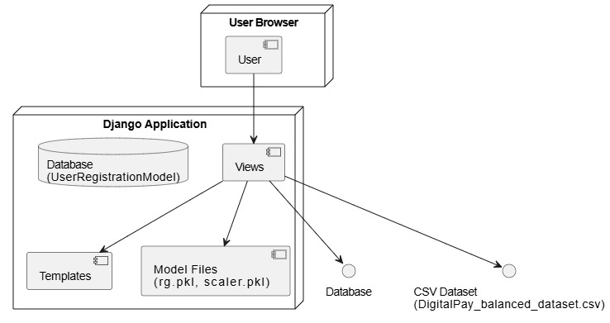

Usecasediagarm:
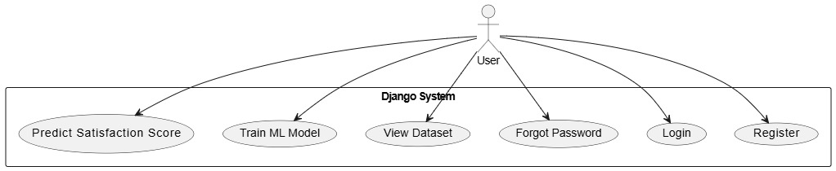

Sequence diagram:

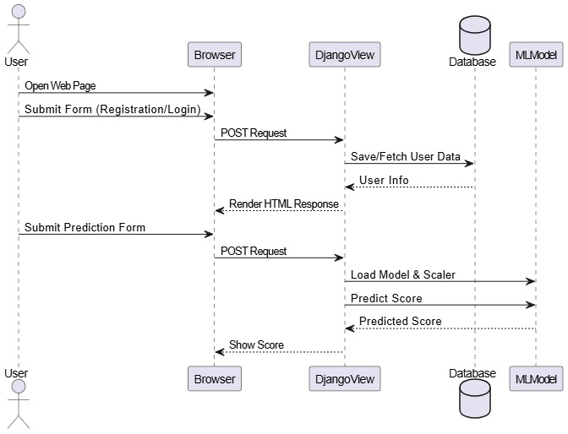

Activity diagram:

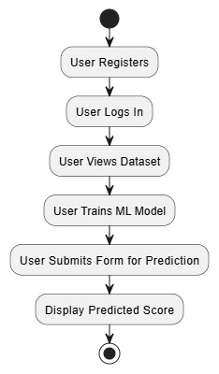

Class diagram:

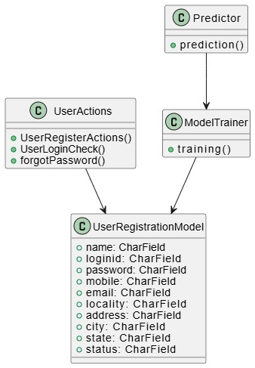

Dataflowdiagram:

